Customer Setup Validation Integration Process

Purpose: This document covers the process of validating the setup checks related to the below Customer entities.

1. Customer accounts
2. Customer/Site Profiles
3. Tax Registration
4. Tax Classification

Requirement: To validate the Customer setups from EBS to fusion so that before import we can get the list of errors if any to avoid any failure during import.

Process: A scheduled integration has been created for this which can be run once transform is completed. By default ALL will be passed in p_validation_type but we can pass the comma separated values for different set of validations.

Values which can be passed for specific type of validation (one or many):

CUSTOMER_CLASS_CODE, STANDARD_TERM_NAME, TAX_REGIME_CODE, CLASS_CODE

Integration Name: INTDM99999_CUST_VALIDATION (01.00.0000)

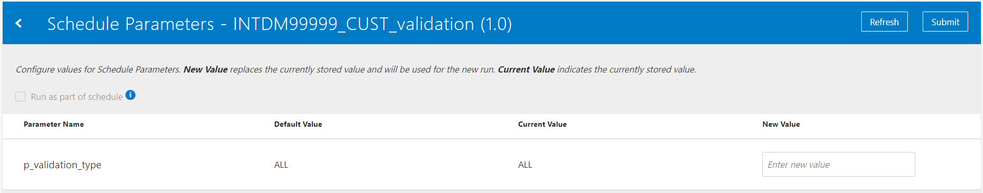

Integrations starts with the deletion of all the data from following tables using db adapters.

Table Names:

1. xxmx_cust_class_code
2. xxmx_term_names
3. xxmx_tax_regime_code
4. xxmx_class_codes

Please note that we can improve this integration further to include the following missing setups:

1. STATEMENT_CYCLE_NAME
2. CLASS_CATEGORY
3. CLASSIFICATION_TYPE_CODE
4. CLASSIFICATION_TYPE_NAME

Then Integration calls the report from fusion environment, output of the report gets coverted from encodedbase64 to opaque schema. Read operation then uses the file reference from write response and convert it into readable format and then data gets inserted into above tables.

Below are the list of reports that are being called.

1. /Custom/Maximise Data Migration/Reference Data Reports/Customers/Customer Class Code - Report.xdo
2. /Custom/Maximise Data Migration/Reference Data Reports/Customers/Customer Term Names - Report.xdo
3. /Custom/Maximise Data Migration/Reference Data Reports/Customers/Customer Tax Regime Code - Report.xdo
4. /Custom/Maximise Data Migration/Reference Data Reports/Customers/Customer Fiscal Classification Code - Report.xdo

Once all the latest data is loaded from fusion into the above tables, a procedure is being called to insert the Maximise transformed data into XXMX_CUSTOMER_VALIDATION table with status ‘N’ and then validate process will be called to validate all the setups.

Below is Package being called for the insertion into XXMX_CUSTOMER_VALIDATION and validating the same.

If any difference is found between Cloud and Maximise then that setup check value is stamped with a status of ‘E’, else it is left with the original status of ‘N’.

Procedure:

1. xxmx_validate_customer_setup_pkg.insert_data
2. xxmx_validate_customer_setup_pkg.validate_data